Critical Making
Project Outside of Course Scope, Spring 2024
2023-10-24

Content
Practicalities 3
Your Teachers 3
Timelines & Dates 4
Info Session 4
HCC Open House 4
Deadline for Applications 4
Application Results 5
Networking & Group Making 5
Official Course Registration 5
Project Course 5
Contract Information 6
Personal Information 6
Information About Main Supervisor 6
Information About the Project Period 7
The Focus of the Project 7
Project Outside the Course Scope as Group Project 12
Information About Supervision 12
Signatures 13
Exam Format 14

Practicalities
This is a 15 ECTS project course that runs in Block 3 & 4.

We want to change the narrative of how Neurodiversity in Computer Science is pictured and we want to do this by combining art and technology, inspired by the GRACE project (http://www.femtech.dk/artifacts/grace-squishing-bugs-in-the-system/).

The project will be structured like a course with key milestones in a timeline that we will all work under. We will provide you with literature, teaching and knowledge as well as giving you feedback and input for the final product and report.

You will work in smaller groups of 2-3 people throughout the entire project, and in these groups you will also create a report in the end. This report will be a reflexive report which will be the baseline for the exam. The exam will be a portfolio exam type in groups – don’t worry, we will provide you with templates and guidance all the way through the project so you are 100 % ready when the exam dates arrives.

There is room for 10 students total and is available for both Master & Bachelor students.

Your Teachers
Pernille Bjørn Deputy Head of Department for Research & Professor
Overall responsible for this project. Pernille will also be running the
examination at the end of the course.

Jenny Vej Research Assistant, Computer Science Teacher, DEI/ADHD/Autism Expert & Project Manager
Jenny has a MSc from DIKU, works as a Project Manager in IT next to this job, has a podcast about living with ADHD & Autism, and will be responsible for the structure of the course as well as teaching.

Ellie Thrane Christensen Research Assistant, Accessibility Expert & Teacher
Ellie will be a teacher for your as well as being responsible for the contact to external partners such as the Danish Autism organization.

Kellie Anne Dunn PhD, Design & Maker Space Expert
Responsible for maker space focused teaching as ell as providing assistance to the students in 3D printing & laser cutting.

Morten Engell-Nørregård Lab Manager & Maker Space Expert
Valeria Borsotti PhD DEI researcher and DEI Expert

Timelines & Dates

Info Session
October 10, 2023 - 16:00-17:00 - SCI-DIKU-sigurdsgade-0-11
We will meet at DIKU, Universitetsparken 1, at the main entrance 15:45 and walk together to Sigurdsgade as we are aware, many might not know where it is.

This session will be an opportunity to meet some of the teachers. We will share more information about the project, how it will be running and have time for questions if you have any.

HCC Open House
October 25, 2023 – 14:00-17:00 – Sigurdsgade 41
Read more here: https://di.ku.dk/english/event-calendar-2023/hcc-open-house/

Deadline for Applications
November 1st, 2023 – end of day
As we only have room for 10 students, we will need to get an application from you. The application should be send by email to Jenny Vej on jvej@di.ku.dk. You will receive a confirmation email latest the day after.

You can apply as an individual or as a group, and we have listed here what kind of information your application should contain.

- Are you applying as an individual or as a group?
  - Please specify name(s) and email-address(es)
- Are you a Master or Bachelor student?
- Why do you want to participate in this project?
- What are some awesome skills you are bringing with you? Are you great at programming, do you play music, crochet, play a specific sports discipline or something completely else?
- What are your expectations for collaborating with fellow students?
- What other courses will you be following in Block 3 & 4 and what days are those scheduled?
- Are you able to participate in this project on Tuesdays from 13:00-16:00?
- We are talking with Roskilde Festival (https://www.roskilde-festival.dk/en/) about a possible collaboration. They work a lot with inclusion and diversity, and we believe that we can learn from each other’s work. The Festival will open the doors to the camping area on Saturday, June 29th and have different activities and small music performances from June 30th through July 2nd. On July 3rd the big music area will open up. We think it could be fun to showcase our artefacts and project at the festival – we don’t know yet if it will be all days or only some of them, but we expect it would be between 11:00 and 17:00. We will provide tickets for the festival, and probably also some food and snacks for when we are ‘working’. The rest of the time would be yours to spend as you please.
Would you be interested in participating in this? OBS: IT IS NOT AT ALL MANDATORY OR EXPECTED AND YOUR ANSWER WILL NOT HAVE AN IMPACT ON YOUR APPLICATION.

Application Results
November 3rd, 2023 – end of day
This is the day you can expect to get a reply on your application. We will reply to all applicants, and when we go through the applications, this is what we will look for participants…:

- that are interested in collaborative work
- that are self-driven and proactive as the project rely on student input
- that are open-minded and ready to learn about critical design and people that might be different from themselves

Further, we will do our best to put together a diverse group of students both in regards to skills and backgrounds.

Networking & Group Making
November 14, 2023 – 15:00-17:00 – SCI-DIKU-sigurdsgade-0-11
The selected students for the course will meet up for a networking event where we will talk about the project, get to know each other, and form groups. All projects needs a project contract – at this event, we will give you the information you need to fill this contract out.

Official Course Registration
November 15 – November 30, 2023
Just like every other course, you will need to register through the official course registration.

Project Course
The project will start on Tuesday, February 6, 2024 – 13:00-16:00.

We will have all our teaching and potential stakeholder meetings in this time slot if at all possible. Further, this time slot is also where you can schedule time for supervision and guidance. Please see the detailed schedule in the section below.

Outside these hours, you can send potential questions or comments to Jenny by email on jvej@di.ku.dk and she will do her best to reply to you within 24 hours during (except from weekends).

We are not scheduling anything during Easter, the exam week for block 3 or the study breaks.

The project will end with you handing in a report made by the group you are working in together with the artefact.

Deadline for the report will be June 11 at 14:00 with the exam in week 25 – most likely June 18 between 13:00 and 16:00 (this will be confirmed later).

For a more elaborate timeline, please go to the Contract Information section below.

Contract Information
It is mandatory to hand in a project contract. You can find the form here: https://kuforms.ku.dk/xform/frontend/FormEngine/v2/ShowForm.aspx?alias=SCI3986&groupId=2&doctype=5.

We have prepared what you need to write in the contract to help you out – all groups will be handing in the same, as we all work on the same overall project with the same learning objectives.

The contract needs to be handed in when it is possible through Absalon/KUnet <AWAITING CONFIRMATION >

Please see the following sections on what to add in the different contract sections.

Personal Information
Here you add your KU-Username, first name, last name, email, phone number, and education – example is shown in Figure 1.

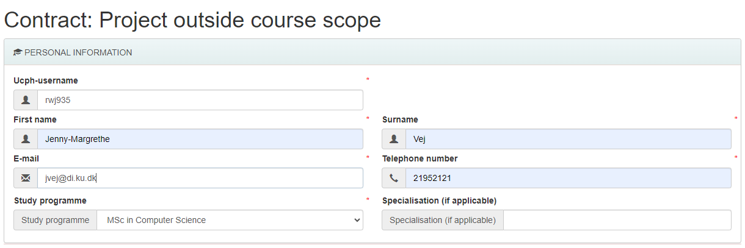
Figure 1: Personal information in project contract

Information About Main Supervisor
You will be getting supervision from Pernille, Jenny, Ellie & Kellie, but Pernille will be your main supervisor. Pernille’s information is shown in Figure 2.

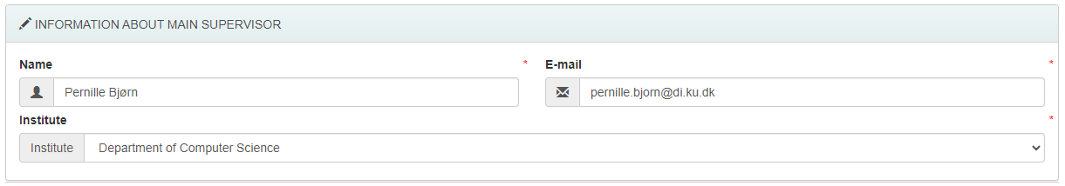
Figure 2: Information about main supervisor

Information About the Project Period
<AWAITS CONFIRMATION IF THE PROJECT COUNT AS BOTH OR ONLY ONE>

The project can be covering both restrictive elective and elective ECTS so mark both. You will get 15 ECTS for the project, it will run in the spring semester so Block 3 and 4, submission date is June 11, and the exam will be a portfolio exam. Figure 3 illustrates how to fill out this part and below we have a section explaining the exam format.

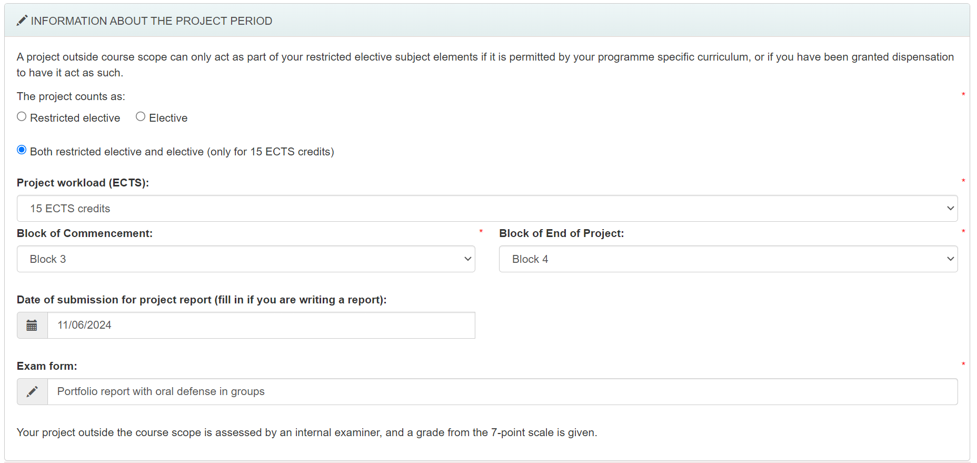
Figure 3: Information about the project period

The Focus of the Project
Click the checkbox, that the project is prepared as a group project.

Please mark what language you will hand in your report in. Master students will have to choose English – Bachelor students can choose either.

Title of the project: “Critical Making”

Description:
In the description field, you will write, that you have made a separate document with the full description. The field in the form is not big enough to contain all the necessary information, so please just refer to the document you will write with this information. See Figure 4 as example.

Then create the document for attachment with the following information:

RESEARCH QUESTION
<IN THE MAKING >

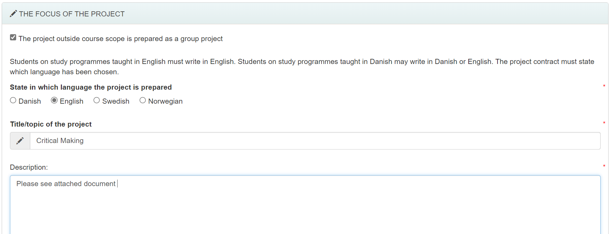
Figure 4: The focus of the project

MOTIVATION & BACKGROUND
<IN THE MAKING>

METHOD & SCOPE
<IN THE MAKING>

TASKS & SCHEDULE
The full schedule of the project will look like this: <PENDING CONFIRMATION AND POTENTIAL CHANGES>

WEEK | SCHEDULED | STUDENT TASKS
Week 6 | February 6, 2024 - 14:15-16:30:  Introduction to participants  Introduction to project course  Learning objectives  Inspirational kick-off talk  Initial group work kick-off | Preparation:  Prepare provided material on critical design  During the week:  Prepare questions for the Danish Autism Association next week
Week 7 | February 13, 2024:  14:15-15:00  Students will present their prepared questions and give suggestions and feedback to each other  15:15-16:00  Danish Autism Association visits  16:00-16:30  Discuss outcomes and learnings as well as preparation for next week | Preparation:  Prepare provided material on neurodiversity  During the week:
Week 8 | February 20, 2024:  14:15-15:00  Introduction to user centred design  15:15-16:30  Ideation workshop – develop ideas | Preparation:  Prepare provided material on user centred design by Buxton  During the week:
Week 9 | February 27, 2024  14:15-16:30  Introduction to makerspace  What are the limitations and possibilities?  Goal:  All groups have 3D printed something small, laser cut something and made a microcontroller blink | Preparation:  Prepare provided material on 3D printing, laser cutting, micro controllers, e-textiles etc.  During the week:
Week 10 | March 5, 2024  14:15-15:00  What is critical design?  15:15-16:00  Introduction to exploratory prototyping  16:00-16:30  The groups choose what idea from their ideation process in week 8 they want to continue with throughout this project | Preparation:  Re-visit provided material on critical design  During the week:  Use the knowledge from explorative prototyping to develop prototypes for the chosen project idea
Week 11 | March 12, 2024 – 14:15-16:30  Office hours for guidance (project & report as well as makerspace) | Preparation:  Book time for support in makerspace and/or general guidance / supervision in advance  During the week:  Work on idea/concept
Week 12 | March 19, 2024 – 14:15-16:30  Office hours for guidance (project & report as well as makerspace) | Preparation:  Book time for support in makerspace and/or general guidance / supervision in advance  During the week:  Work on idea/concept
Week 13 | EASTER WEEK
Week 14 | EASTER WEEK
Week 15 | EXAM WEEK FOR BLOCK 3
Week 16 | STUDY BREAK WEEK
Week 17 | April 23, 2024 – 14:15-16:30  Groups present concept and current version of artefact in a presentation – exam simulation  Groups will provide feedback and input to each other  Representatives from IDA Neurodiversity group will be present and also provide feedback to the groups | Preparation:  Presentation as if it was an exam  During the week:  Work on idea/concept and prepare for visitors next week
Week 18 | April 30, 2024  14:14-15:00  Revisit of critical design  15:15-16:30  Maybe we will have visitors from Roskilde Festival or someone else? If so, students will present their work so far and discuss with visitors ideas for improvements and changes | Preparation:  Revisit provided material on critical design  During the week:  Work on idea/concept
Week 19 | May 7, 2024 – 14:15-16:30  Office hours for guidance (project & report as well as makerspace) | Preparation:  Book time for support in makerspace and/or general guidance / supervision in advance  During the week:  Work on idea/concept
Week 20 | May 14, 2024 – 14:15-16:30  Office hours for guidance (project & report as well as makerspace) | Preparation:  Book time for support in makerspace and/or general guidance / supervision in advance  During the week:  Work on idea/concept
Week 21 | May 21, 2024  14:14-15:45  Groups present concept and current version of artefact in a presentation – exam simulation  Groups will provide feedback and input to each other  16:00-16:30  Exam information | Preparation:  Presentation as if it was an exam
Week 22 | May 28, 2024 – 14:15-16:30  Office hours for guidance (project & report as well as makerspace) | Preparation:  Book time for support in makerspace and/or general guidance / supervision in advance  During the week:  Work on idea/concept
Week 23 | June 4, 2024 – 14:15-16:30  Office hours for guidance (project & report as well as makerspace) | Preparation:  Book time for support in makerspace and/or general guidance / supervision in advance  During the week:  Finalise idea/concept as well as report
Week 24 | June 11, 2024 – 14:00  EXAM DEADLINE
Week 25 | June 18, 2024 – 13:00-16:30  EXAM  Each group will have 7 minutes per student for presentation and 10 minutes total for discussion.
Week 26 | June 29, 2024 – Roskilde Festival open its doors for guests  June 30, 2024 – First official Roskilde Festival ‘non-music’ day
Week 27 | July 3, 2024 – Music area opens at Roskilde Festival  July 6, 2024 – Last music day

LEARNING OBJECTIVES
By the end of this project course, the student will have

Knowledge of
- Theories on critical design
- User centred design in makerspaces
Skills to
- Analyse the barriers of neurodivergent groups
- Innovate through iterative prototyping and critical design in a makerspace
Competences to
- Analyse invisible barrier and ‘taking-for-granted’ assumptions in applying user centred design
- Design critical artefacts challenging ‘taking-for-granted’ assumptions
- Innovate and push boundaries of Computer Science as a field

REFERENCES & LITERATURE

Critical Design
- Bardzell, S., J. Bardzell, J. Forlizzi, J. Zimmerman and J. Antanitis (2012). Critical design and critical theory: The challenge of designing for provocation. DIS. NewCastle, UK. Hertz, G. (2012). Critical Making, Telharmnonium Press.
- Ratto, M. (2011). "Critical making: Conceptual and material studies in Technology and Social life." The Information Society 27: 252-260.
- Bentley, C. M., A. Chib and S. Poveda (2019). "A critical narrative approach to openness: The impact of open development on structural transformation." Information Systems Journal 29(4): 787-810.
- Ogbonnaya-Ogburu, I. F., A. D. R. Smith, A. To and K. Toyama (2020). Critical race theory for HCI. CHI2020. Honolulu, HI, USA, ACM.
- Lindtner, S., A. Greenspan and D. Li (2015). Designed in Shenzhen: Shanzhai manufacturing and maker entrpreneurs. Critical Alternatives: 5th decennial Aarhus Conference. Aarhus, Denmark, ACM: 85-96.
- Mankoff, J., G. Hayes and D. Kasnitz (2010). Disability studies as a source of critical inquiri for the field of assistive technology. ASSETS. Orlando, Florida, USA, ACM.
- Pierce, J., P. Senger, T. Hirsch, T. Jenkins, W. Gaver and C. Disalvo (2015). Expanding and refining design and criticality in HCI. CHI'2015. Seoul, Korea, ACM: 2083-2092.
- Menéndez, M., P. Bjørn and A. D. Angeli (2017). Fostering Cooperative Activism through critical design. In Proceedings of the 2017 ACM Conference on Computer Supported Cooperative Work and Social Computing (CSCW '17). Portland, USA, ACM.
- Fuchsberger, V., M. Murer, M. Tscheligi, S. Lindtner, A. Reiter, S. Bardzell, J. Bardzell and P. Bjørn (2015). The Future of Making: Where Industrial and Personal Fabrication Meet Workshop paper at Critical Alternatives. Århus, Denmark, https://projects.hci.sbg.ac.at/fabrication2015/organizers/.
- Howcroft, D. and E. M. Trauth (2008). "The implications of a critical agenda in gender and IS research." Information Systems Journal 18(2): 185-202.
- Mallipeddi, N. and R. VanDaalen (2022). "Intersectionality within critical autism studies: A narrative review." Autism Adulthood 4(4): 281-289.
- Ko, A. J., A. Oleson, N. Ryan, Y. Register, B. Xie, M. Tari, M. Davidson, S. Druga and D. Loksa (2020). "It is time for more critical CS education." Commun. ACM 63(11 (November 2020) ): 31–33.
- Bardzell, J., S. Bardzell and E. Stolternan (2014). Reading critical design: Supporting reasoned interpretations of critical design. CHI. Toronto, Canada, ACM
- Ross, E. W. and L. Hannay (1986). "Towards a critical theory of reflective inquiry: Theme." Journal of Teacher Education 37(9): 9-15.
- Bardzell, J. and S. Bardzell (2013). What is 'critical' about critical design? CHI'2013, ACM: 3297-3306.
- https://inclusive.microsoft.design/
- https://www.inclusivedesigntoolkit.com/whatis/whatis.html

Neurodiversity
- Borsotti, V., A. Begel and P. Bjørn (submitted). "Neurodiversity and the accessible university: exploring organizational barriers, access labor and opportunities for change."
- Spiel, K., C. Frauenberger, O. Keyes and G. Fitzpatrick (2019). "Agency of autistic children in technology research - a critical literature review." ACM Trans. Comput.-Hum. Interact. 26(6): 1-38.

User Centred Design
- Buxton – <RELEVANT CHAPTERS TO BE DECIDED ON>
- https://www.amazon.com/Measuring-User-Experience-Interactive-Technologies/dp/0128180803/ref=sr_1_2?crid=2XN8BB0J4VZUG&keywords=measuring+the+user+experience+albert+tullis&qid=1696929878&s=books&sprefix=measuring+the+user+experience+albert+tullis%2Cstripbooks%2C174&sr=1-2

Makerspace
- <RELEVANT MATERIAL ON ITS WAY>

Project Outside the Course Scope as Group Project
Please add the members of your group here and check the boxes that the project is prepared as a Joint report with a Group Exam as seen in Figure 5.
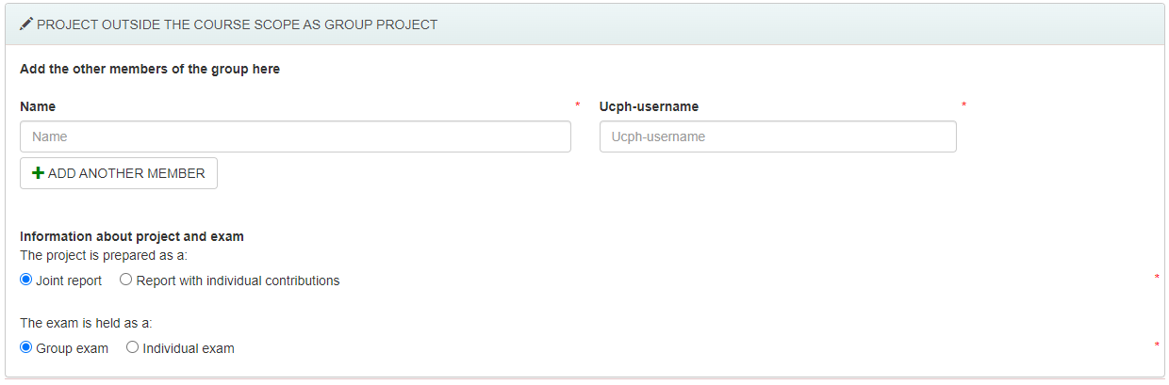
Figure 5: Project outside of scope as a group project

Information About Supervision
Expected hours of supervision: 5-10.
State how often you need to meet: We will agree based on group needs and confidence throughout the project. It will be possible to meet in person every week in regular weeks and to get feedback and input online throughout the entire period. It is expected, that students will meet up for all scheduled events as a minimum. Please see the task & schedule list in attached document.

State what is expected of the supervisor at the meetings: For scheduled sessions, supervisor and teachers are prepared to do the sessions and to drive the scheduled activity. For booked supervision, the supervisors will have prepared feedback when relevant as well as answers to questions received at least 24 hours before the meeting.

State what is expected of the students at the meetings: To show up prepared. Material for each session will be available online before the project begin for the students to prepare according to their schedule. Before supervision sessions, students will have prepared what they want supervision and advice on and send that to relevant supervisors at least 24 hours before the meeting.

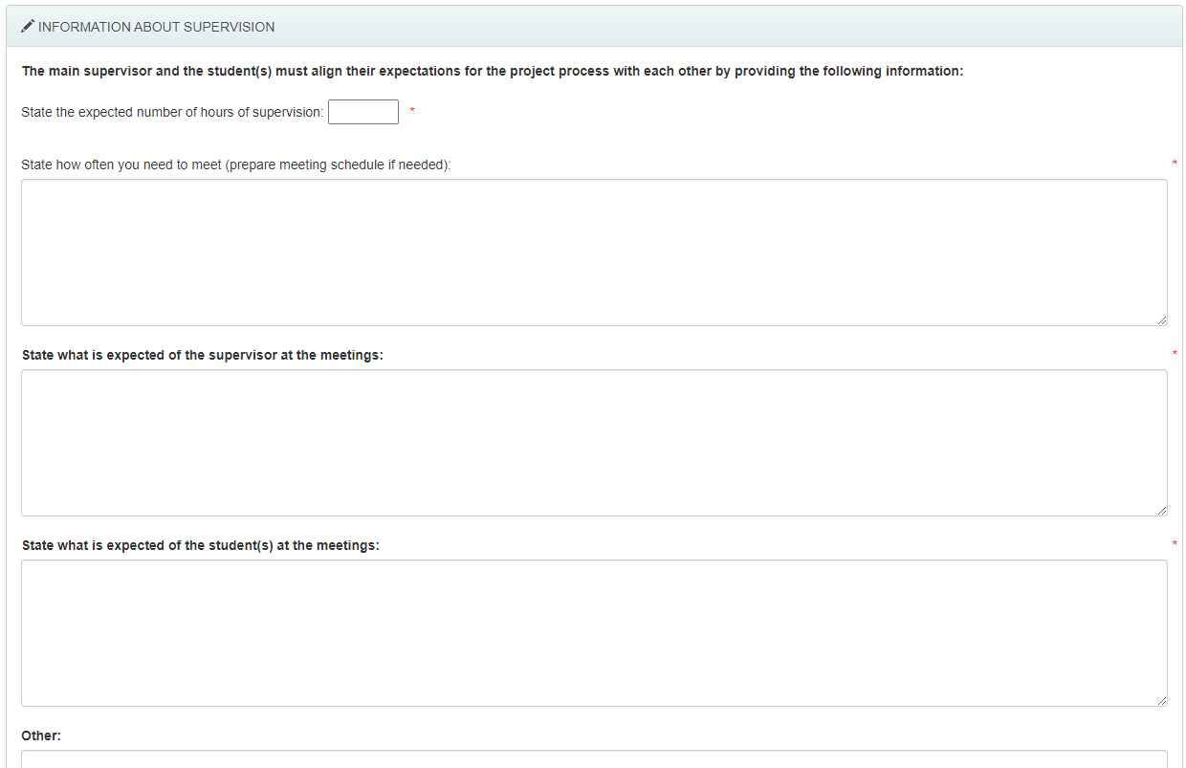
Figure 6: Information about supervision

Signatures
<HOW TO IS ON ITS WAY>

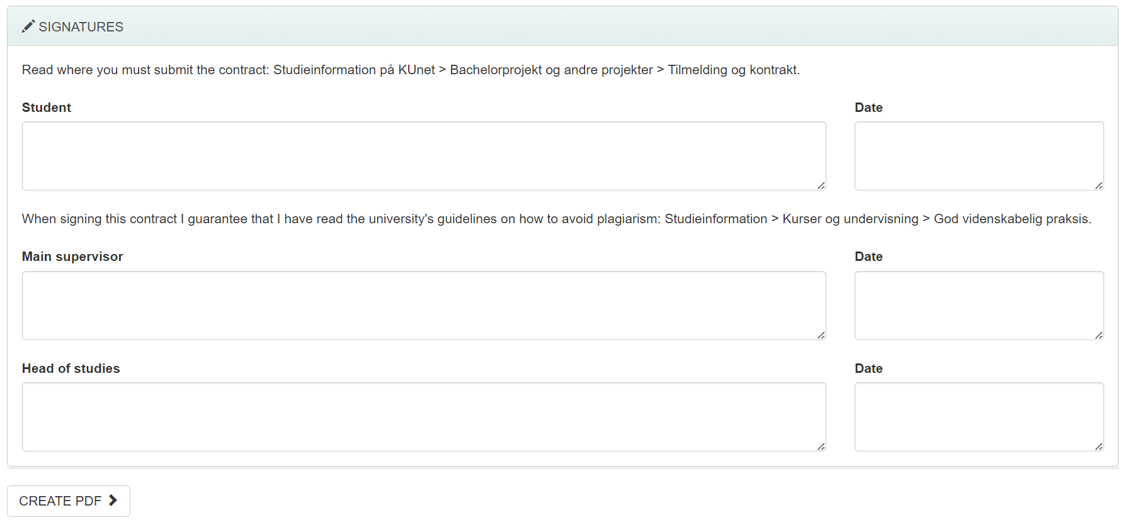
Figure 7: Signatures

Exam Format
<FORMAT, GUIDE AND TEMPLATES IS ON ITS WAY>

